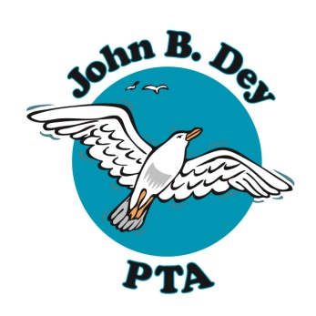
John B. Dey Elementary School Parent Teacher Association
1900 N. Great Neck Road Virginia Beach, VA 23454
www.jbdpta.com

Minutes for Thursday, October 24, 2019 GENERAL Meeting
Date of Meeting: October 24, 2019
Time of Meeting: 5:30pm
Meeting to be held at: John B. Dey Elementary Cafeteria
In attendance: Over 50 parents for Reflections Ceremony and Reception
Call to Order at: ___5:40________pm
Welcome- Congratulations to all students for sharing their talents as they entered the Reflections contest this year, and thank you to Marlene Patterson for chairing the contest and the reception. It is a lovely evening.
Officers' Reports
President-Lauren Kirkpatrick
This year the PTA has already been very busy! So far this year we have: hosted a popcorn party at Meet and Greet, had 3 park play dates, welcomed parents at open houses, hosted a back to school lunch for teachers, gave each teacher a $100 voucher for school supplies, donated a Cricut machine to the JBD Maker's Space, Organized tennis, art and Spanish after school programs, organized Kindness Club and Animal Care Club, added potted flowers to the new drop off loop, and organized the Reflections Contest and Awards Reception. In the next week, we will host our 2nd Annual Halloween Costume Parade for the school on Oct 31 and we will begin our spirit wear "TEAM JBD" campaign on Friday, Oct 25.
Our Seagull Circle Fundraiser is going on NOW! Seagull Circle is a sponsorship program in which family members or businesses may sponsor the JBD students. All money donated goes to the PTA to be used for JBD PTA events and to benefit the kids at the school. You may send back the sponsorship form with a check or please go to www.jbdpta.com to donate online. There are various levels of sponsorships, and your name or business name will be proudly displayed on a banner in our cafeteria for all to see!
VP Programs- Jeannie Gray (Presented by Lauren Kirkpatrick)
Fall after school programs (Tennis, Art, Great Gulls Club, and Animal Care Club) are going on now. Spanish will begin in Nov. If you missed sign ups, many of these programs will be offered again in the Spring.
JBD PTA Halloween parade and trick or treating will be on Oct. 31. Students will be allowed to wear their costume to school that day with a donation to United Way (organized by SCA).

MATH NIGHT WILL NOW BE ON NOV.19 AT FOOD LION SHORE DRIVE LOCATION!
For more info go to www.jbdpta.com

Treasurer- Jenny Sessoms
Treasurer's Report
__$28,100.38________________ starting total ______$31,183.89_________ending total
We will now vote to make an amendment to our budget to purchase materials for the Cricut machine for the JBD Maker's Space
Motion to Amend the 2019/20 budget to add $450 to the Gift to School Line Item-
Lisa Flanagan
2nd-Becky Franklin
Motion Passed and $450 will be added to the Gift to School Line Item

Secretary- Susan Wilson
Minutes are posted online and on the new PTA bulletin board located outside of the cafeteria
Motion to approve Sept 2019 minutes-Ashley Knox
2nd-Marlene Patterson
Motion passed and minutes have been approved

VP membership- Erin Collins (presented by Lauren Kirkpatrick)
Please join the PTA!
We currently have 445 paid members and are striving for 100% school wide membership this year! We are very close to 100% JBD staff membership!! Please help us reach our goal- It's not too late to join!
$5 per adult membership cash or check made out to JBD PTA

The next General Meeting will be before the Holiday Concert in December.
We look forward to seeing you there!
We are adjourned. The time is_____5:47__pm.
Mrs. Bianchi-Principal's message to the Reflections Participants
Marlene Patterson-Reflections awards and reception

Submitted by Susan Wilson, JBD PTA Secretary
Approved by: ____________________________________
Lauren Kirkpatrick, JBD PTA President
Date: _____________________________

