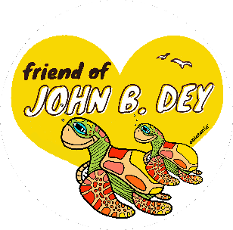

2023 - 2024 Seagull Circle Sponsorships

Sponsorship Benefits Platinum Gold Silver Bronze Friend
($1000 +) ($750+) (500+) ($100+) ($25+)
- Name will be displayed on JBD Marquee for one week | X
- Name/Logo on Field Day T-shirt (all JBD students receive on Field Day) | X | X
- Name/Logo in JBD Yearbook  - Yard Sign with Name/Logo displayed on JBD School grounds during PTA events | X | X | X
- Recognition at all PTA events.  - Shout out on morning announcements.  - Additional PTA Membership | X | X | X | X
- Name/Logo on JBD PTA Website | X | X | X | X
- Social Media shout out on JBD Facebook Page | X | X | X | X
- Limited Edition Friend of JBD Car Magnet  - One PTA Membership | X | X | X | X | X

Please complete the information below so that we can acknowledge your generous donation:

Name (Family or Business):_______________________________________________________
Address:______________________________________________________________________
Phone:_______________________________________________________________________
Email: _______________________________________________________________________
Sponsorship Level (circle one): Platinum Gold Silver Bronze Friend
Name exactly as it should appear on any signs or shirts:

__________________________________________________________________________
Name for 1st PTA Membership__________________________________
Name for 2nd PTA Membership__________________________________

Make Checks payable to: John B. Dey Elementary School PTA
Return to your child’s teacher in an envelope marked “Seagull Circle”
Credit card donations may be made on our www.JBDPTA.com website
All donations are tax deductible Tax ID # 54-1426517
Questions: Contact Wanda Wilson 757-672-4134 or wanda711@cox.net

On behalf of the John B. Dey PTA, Thank You for your Support

