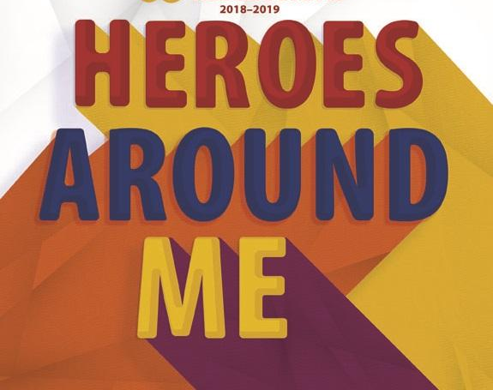

Reflections
Student Entry Form

Deadline to Enter is Friday, Oct. 5, 2018
Ceremony Date is Oct. 25, 2018

Student Name
Teacher/Grade
Parent Name/Phone
Parent Email

Parent Permission:
I give my child permission to participate in the PTA Reflections contest. I certify that this entry was completed by the student with no help from adults or other persons that would affect the creative integrity of the product.

Category (circle):

Visual Art Photography Dance Choreography Literature Video Production

Musical Composition Special Artist

Title of Work (Required): ___________________________________________________

Artist Statement (Required): Communicate your inspiration for the work and how it relates to the theme “Heroes Around Me.” Your statement must contain at least one sentence, and not exceed 100 words. It can be typed and attached, handwritten on this sheet in the space below, or handwritten on a piece of paper and attached.

