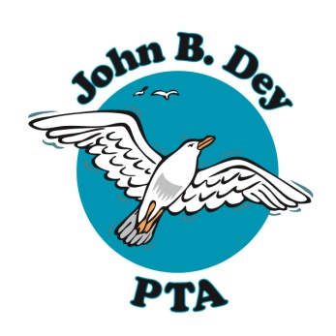
John B. Dey Elementary School Parent Teacher Association
1900 N. Great Neck Road Virginia Beach, VA 23454
www.jbdpta.com

Minutes for Tuesday, February 18, 2020 GENERAL Meeting
Date of Meeting: February 18, 2020
Time of Meeting: 6:30pm
Meeting to be held at: Haygood Skating Rink
In attendance: Over 50 parents in attendance for Skating Party
Call to Order at: ___6:38________pm
Welcome-Thank you for coming tonight to the Valentine's Day Skating party. Because of funds raised through the PTA, we were able to cover a portion of the admission cost for our JBD families. It's because of your generous donations that we are able to do this, so thank you!
Principal's Report, Christa Markert
Thank you for attending this fun event and to the PTA for hosting!
Officers' Reports
Lauren Kirkpatrick, 2019/2020 President
Boosterthon is coming up with pep rallies during school hours on March 2, and the Fun Run on March 12. We are so excited to welcome the Boosterthon team on JBD's campus this year and we have a big goal this year. Later in the meeting we'll vote on the big gift to school. Our gifts to school are so appreciated at JBD and enjoyed by the students and staff. We can't wait to present this year's proposal for gift to school.

Jeannie Gray, 2019/2020 VP Programs (Presented by Lauren Kirkpatrick)
-After school programs are currently on-going and are enjoyed by our students.
-This year's new program, "Marine Life-a mini marine-biology unit" was a huge success and we hope to bring it back next fall.

Jenny Sessoms, 2019/2020Treasurer
Treasurer's Report

__$28, 100.38________________ starting total _______$33,278.12__________ending total

Proposal and Voting on 2019/2020 GIFT TO SCHOOL

The board has approved the following items as a gift to school.
1. 6 benches and 3 bird houses to be purchased from Sunshine and Sweet Pea's to adorn the courtyard (this will be the same bench that's at the front of the school but in various fun and bright colors).
2. A general "pot" of funds to be reserved for teachers; following an approved proposal would have the funds needed for grade specific items that all teachers in that grade can enjoy.
3. Science materials and learning aids for science labs.

Motion to approve the Gift to School as listed Lisa Flanagan
Second Jenn Sadler

The vote passed, and the Gift to School has been approved.

Susan Wilson, 2019/2020 Secretary
Approval of Minutes
Minutes from the December 4th JBD PTA board meeting have been posted for viewing on the PTA bulletin board. Are there corrections to the minutes?
Motion to approve-Melissa McCormack
Second-Lisa Flanagan
Vote to approve Minutes-The motion passed and the minutes will be filed with our records
Minutes can be found on our new PTA bulletin board in the hallway and on our website!

Erin Collins, 2019/2020 VP Membership
Please join the PTA!
$5 per adult membership cash or check made out to JBD PTA
We are 460+ MEMBERS STRONG!

Upcoming Events: Boosterthon information will be coming home soon with your child, and it will be posted on the JBD PTA website and on the JBD PTA website.
Bingo Night is on April 24. There are amazing auction items coming in, and there will be only a limited number of tickets available for pre-sale only. No tickets will be sold at the door.
Please check the PTA website and JBD facebook to keep up-to-date with PTA happenings.
www.jbdpta.com

We are adjourned. The time is__6:44__pm.
Submitted by Susan Wilson, JBD PTA Secretary
Approved by: ____________________________________
Lauren Kirkpatrick, JBD PTA President
Date: _____________________________

